**Airline Customer Satisfaction Analysis**

**Descriptive Statistics:**

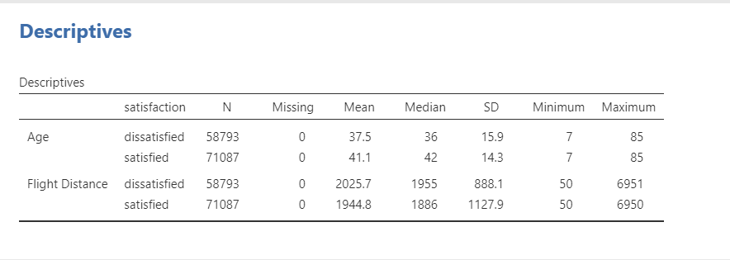

Here’s a description of the dependent and independent variables from the "Airline_customer_satisfaction" dataset:

**Dependent Variable:**

1. **Satisfaction:**
   * Description: This variable indicates whether a customer is satisfied or dissatisfied with their flight experience. It captures the overall sentiment after the flight.

**Independent Variables:**

1. **Age:**

**• Description:** The age of the customer.

**• Type:** Numerical

2. **Flight Distance**:

* **Description**: The distance of the flight in miles.
* **Type**: Numerical.

The screenshot shows a table of descriptive statistics for two variables: Age and Flight Distance. The table is organized by satisfaction level (dissatisfied and satisfied).

For each variable and satisfaction level, the following statistics are provided:

* **N:** The number of observations.
* **Missing:** The number of missing observations.
* **Mean:** The average value.
* **Median:** The middle value when the data is sorted.
* **SD:** The standard deviation (a measure of spread).
* **Minimum:** The smallest value.
* **Maximum:** The largest value.

Here are some key observations from the table:

* The sample sizes for both satisfied and dissatisfied groups are relatively large.
* There are no missing observations for either variable.
* The average age of dissatisfied passengers is slightly lower than that of satisfied passengers.
* The average flight distance is slightly higher for dissatisfied passengers.
* The standard deviation for both age and flight distance is relatively high, indicating that there is a wide range of values within each group.

**Hypothesis:**

**Hypotheses for the Airline Customer Satisfaction Analysis**

**Based on the descriptive statistics, here are some potential hypotheses:**

**Hypothesis 1: Flight distance is associated with passenger satisfaction.**

* **Null Hypothesis (H0):** There is no significant difference in the average flight distance for satisfied and dissatisfied passengers.
* **Alternative Hypothesis (H1):** The average flight distance for satisfied passengers is different from the average flight distance for dissatisfied passengers.

The screenshot shows the results of a regression analysis. The model is used to predict flight distance based on passenger satisfaction.

**Regression Equation:**

* **Flight Distance = 2025.71 + 0.0 satisfaction dissatisfied - 80.94 satisfaction satisfied**

This equation indicates that the predicted flight distance is equal to 2025.71 miles, plus 0.0 miles for each dissatisfied passenger, minus 80.94 miles for each satisfied passenger.

**Coefficients:**

* **Constant:** 2025.71
  + The predicted flight distance when both satisfaction dissatisfied, and satisfaction satisfied are zero.
* **satisfaction satisfied:** -80.94
  + For each increase of one unit in satisfaction satisfied (i.e., going from 0 to 1), the predicted flight distance decreases by 80.94 miles.

**Model Summary:**

* **S:** 1026.33
  + The standard error of the estimate, which measures the average distance between the predicted flight distance and the actual flight distance.
* **R-sq:** 0.15%
  + The R-squared value, which indicates the proportion of variance in flight distance explained by the model. In this case, only 0.15% of the variance in flight distance is explained by the model.
* **R-sq(adj):** 0.15%
  + The adjusted R-squared value, which takes into account the number of predictors in the model. It is slightly lower than the R-squared value.
* **R-sq(pred):** 0.15%
  + The predicted R-squared value, which estimates the R-squared value that would be obtained if the model were applied to a new dataset.

**Overall, the model suggests that passenger satisfaction has a significant negative effect on flight distance.** As satisfaction increases, flight distance tends to decrease. However, the model explains a very small proportion of the variance in flight distance, indicating that other factors are also important in determining flight distance.

**Analysis:**

The image shows the results of a binomial logistic regression model. The model was used to predict passenger satisfaction (satisfied vs. dissatisfied) based on arrival delay, departure delay, inflight wifi service, and inflight entertainment.

**Model Fit Measures:**

* **Deviance:** 116234
* **AIC:** 116260
* **R² McFadden:** 0.348

These values indicate that the model fits the data reasonably well, but there is still room for improvement.

**Model Coefficients:**

* **Intercept:** 1.65080
* **Arrival Delay in Minutes:** -0.00816
* **Departure Delay in Minutes:** 0.00309
* **Inflight wifi service:** 
  + **1-0:** -1.63450
  + **2-0:** -0.88023
  + **3-0:** -0.89397
  + **4-0:** -0.62819
  + **5-0:** -0.72890
* **Inflight entertainment:** 
  + **1-0:** -1.89162
  + **2-0:** -2.24980
  + **3-0:** -2.07873
  + **4-0:** 0.19386
  + **5-0:** 2.25604

The coefficients represent the change in the log odds of satisfaction for a one-unit increase in the corresponding predictor. For example, a one-minute increase in arrival delay is associated with a decrease in the log odds of satisfaction by 0.00816**.**

**Odds Ratios:**

* The odds ratios are calculated by exponentiating the coefficients. They represent the change in the odds of satisfaction for a one-unit increase in the corresponding predictor. For example, a one-minute increase in arrival delay is associated with a decrease in the odds of satisfaction by 0.992.

**Overall,** the model suggests that both arrival delay and inflight wifi service are significant predictors of passenger satisfaction. Passengers are more likely to be dissatisfied with their flight if they experience longer arrival delays or poor inflight wifi service. However, the effect of departure delay and inflight entertainment on satisfaction is relatively small.